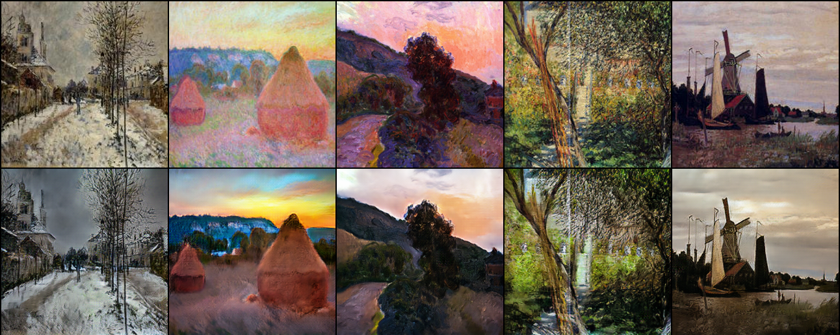

**Business Problem:**

Misdiagnosis in the medical field is a very serious issue but it’s also uncomfortably common to occur. Imaging procedures in the medical field requires an expert radiologist’s opinion since interpreting them is not a simple binary process (Normal or Abnormal). Even so, one radiologist may see something that another does not. This can lead to conflicting reports and make it difficult to effectively recommend treatment options to the patient.

One of the complicated tasks in medical imaging is to diagnose MRI (Magnetic Resonance Imaging). Sometimes to interpret the scan, the radiologist needs different variations of the imaging which can drastically enhance the accuracy of diagnosis by providing practitioners with a more comprehensive understanding.

But to have access to different imaging is difficult & expensive. With the help of deep learning, we can use style transfer to generate artificial MRI images of different contrast levels from existing MRI scans. This will help to provide a better diagnosis with the help of an additional image.

**Approach:**

CycleGAN a variant of Generative Adversarial Network is great choice to solve this problem. It generates quite high-quality images and the main advantage of CycleGAN is it does not require paired data. paired data is very difficult obtain and expensive to collect. Sometimes paired data doesn’t even exist.

**Data Understanding:**

In dataset there are two kind of images., T1-weighted MRI and T2-weighted MRI images. Both types of MRI contrast different regions within the body. And both serve different purposes.

**T1-weighted →** fat issue appears to be bright

**T2-weighted →** both fat and water regions appear to be bright

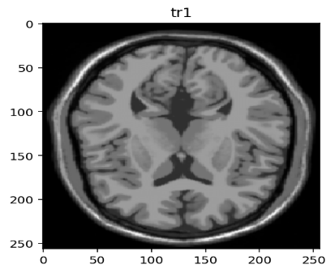 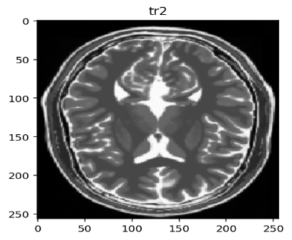

**Data Pre-processing:**

**Image Resizing:** The images were of different sizes, so I resized it to 256 x 256. Now all the images have same size.

**Image Normalization:** normalization very critical step in pre-processing. It helps in gradient propagation. Normalizing the image here between -1 to 1.

**Augmentation:** it helps to increase the training data, but not all augmentation techniques work in every situation. Here we are not going to see the images upside down, as MRI images are scanned with a particular procedure. There is chance that we might see side flipped images. So here random flip is used to augment data.

**Model Building:**

**Hyper-parameters:**

**Drop out =** to avoid overfitting.

**LAMBDA =** LAMBDA is deciding the weights of Cycle consistency loss and Identity loss, after experimenting with different values, 1 was giving better results.

**LAMBDA adversarial=** LAMBDA adversarial decides weightage of discriminator loss, 0.5 giving good results

**Adam optimizer** is used here with small learning rate, and further decaying the learning rate for smooth training.

**EPOCHS =** No of iterations

**Network Architecture**

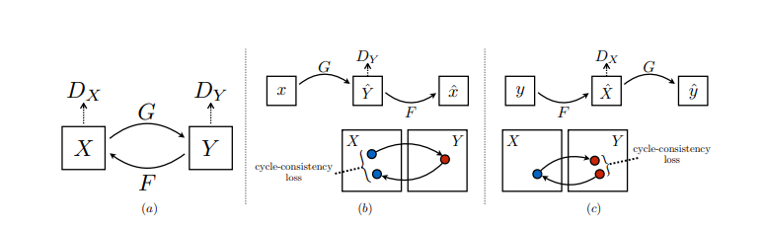

CycleGAN consist of 2 Generators and 2 discriminators.

**For X domain to Y domain:**

* Generator G translate image from X domain to Y domain. Discriminator Y will decide translated image belongs to Y domain or not.
* Generator Y will try to reconstruct original X domain image from translated Y domain image. Discriminator X will decide reconstructed image is same as original X domain image or not.

**For Y domain to X domain:**

* Generator F translate image from Y domain to X domain. Discriminator X will decide translated image belongs to X domain or not.
* Generator X will try to reconstruct original Y domain image from translated X domain image. Discriminator Y will decide reconstructed image is same as original Y domain image or not.

**Architecture of Generator (U-net):**

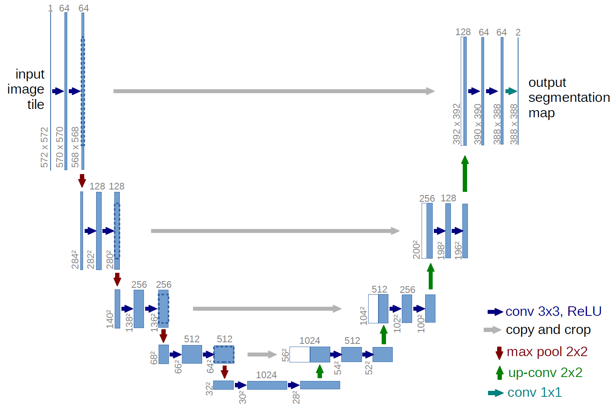

U-net consists of a contracting path and an expansive path, similar to encoder, decoder architecture.

keeping the size of output image to 256 x 256, same as the size of input image domain.

Through Copy and crop layer or skip connection layer we transfer some information from X domain image to decoder side because we want a very particular translation.

For e.g. In famous zebra-horse translation, we just want to replace horse with zebra, without changing surrounding and background. These skip connections help to achieve this.

**Architecture of Discriminator:**

Discriminator in CycleGAN same as CNN binary classifier.

**Loss Functions:**

**Adversarial loss:** Both generators are attempting to “fool” their corresponding discriminator into being less able to distinguish their generated images from the real versions.

However, the adversarial loss alone is not sufficient to produce good images, as it leaves the model under-constrained. It enforces that the generated output be of the appropriate domain, but does not enforce that the input and output are recognizably the same.

**Cycle consistency loss:** It relies on the expectation that if you convert an image to the other domain and back again, by successively feeding it through both generators, you should get back something similar to what you put in.

**Identity loss:** It enforce that CycleGAN preserves the overall colour structure of the picture. It introduces a regularization term that helps to keep the tint of the picture consistent with the original image.

**Checkpoints:** saving checkpoints at regular interval.

**Training:**

We have total 4 networks in place, and at a time only one network should be trained. Suppose discriminator had successfully caught the fake one. It means generator needs to improve itself. If generator able to fool discriminator, then discriminator needs to improve itself. I used TensorFlow’s inbuilt functionality to achieve given condition.

At the end of 200 epochs,

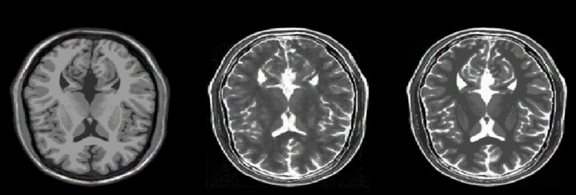

Average Generator loss G at epoch 200: 0.81

Average Generator loss F at epoch 200: 0.77

Average Discriminator loss X at epoch 200: 0.69

Average Discriminator loss Y at epoch200: 0.67

**Model Testing**

Predicted image and Expected image looks pretty much similar. so, we can say that, model is performing style transfer decently on training side.

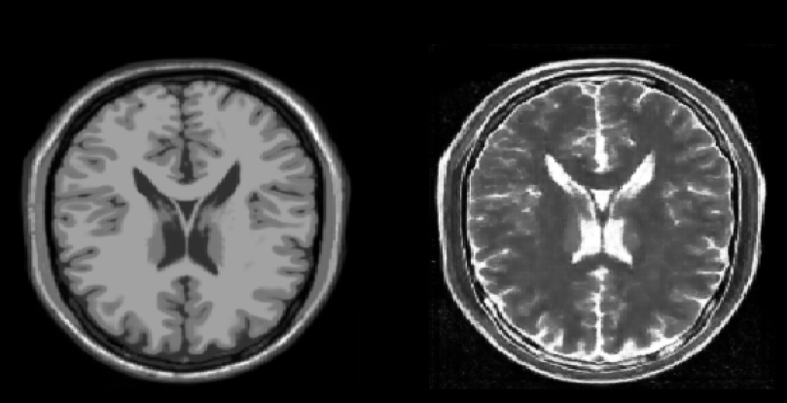 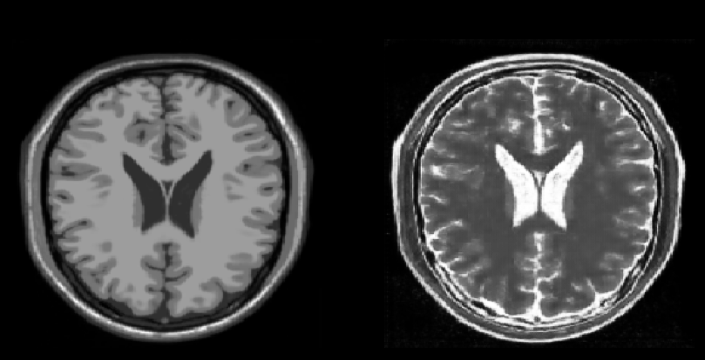

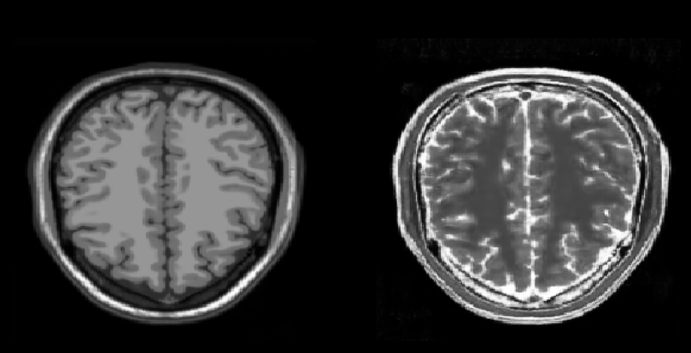 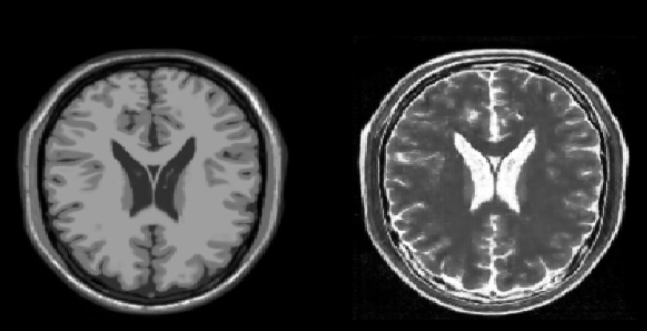

On testing side also, we can see that, images from T1 domain decently translated to T2 domain.

**CycleGAN can be leveraged to synthesize MRI images of any contrast levels! Moreover, it can even potentially be deployed accurately derive CT scans, PET scans, X-rays and etc. from MRI scans and vice versa!**